1. 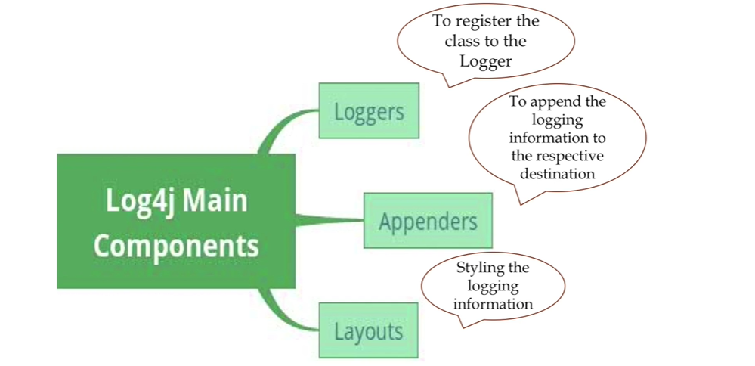 **Loggers**: When you have written a class file and in order to get the logging info about that particular class, we will be using logger.
   1. To register the class to the logger.
   2. To takes log info and then print that info on appropriate destination.
   3. **Example**: Logger logger = Logger.getLogger(com.jatin.Account.class);
2. **Appenders**:
   1. Responsible to publish logging info to various destinations such as DB, File, Console.
3. **Layouts**:
   1. Responsible to style logging info.